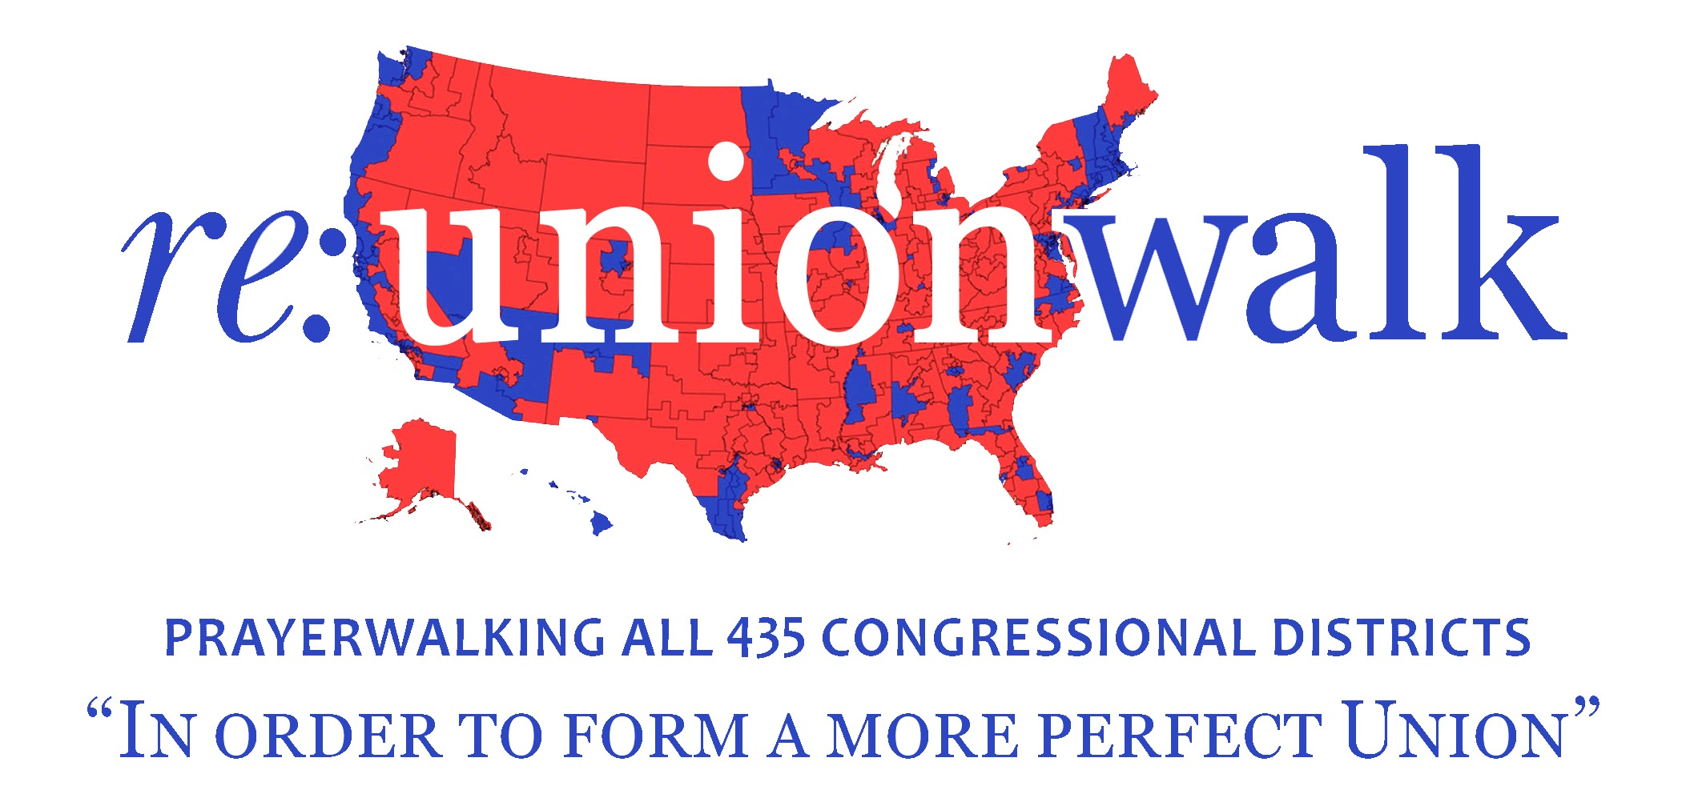

An Intercessory Appeal to Heaven on behalf of God’s Servant,
The Honorable Kevin Cramer
J
ust as an artist combines reds and blues to create royal hues of purple, we believe when We the People come together under the Master’s Hand in genuine unity, we transcend the earthly realm of political party-demarcation and step into the majesty of God’s Kingdom. Here, He exhorts us to pray for one another as a “first of all” priority, especially for those He has empowered with governmental authority. And so…
W
e, the undersigned pastors and ministerial leaders, in agreement with the Body of Christ gathered here today, do hereby lift up and bless God’s appointed servant, the Honorable Kevin Cramer, Representative of North Dakota, along with his family, his esteemed staff and colleagues, and his fellow citizens of North Dakota’s At-Large Congressional District, as we pray together in the Mighty Name of Jesus:
Lord, have mercy on us! We believe there is one body and one Spirit, yet we come before You fractured and fragmented—segregated by common offense and prostituted by partisanship. Forgive us, O God. Help us discern the counterfeit-unity of polarization, that we might become Your ambassadors of reconciliation. Keep us grounded in Your strength, as You strengthen us to find common ground with all Your children.
Make us one—brothers and sisters endeavoring to keep the unity of the Spirit in the bond of peace. As we abide in Your love and walk in Your precepts, pour out Your wisdom, humility, honor, compassion, justice, generosity, prosperity and hope. May Your joy overflow through us until it floods our communities—until we all become rich in friends, serving one another out of Christlike love, with no strings attached.
Lord, You are good and Your mercy endures forever. Thank You for Your favor that lasts a lifetime! Pour out Your Spirit on the At-Large District of North Dakota, especially on Your servant, Kevin, as he seeks You with all his heart. AMEN.
Signed on Election Eve, this 5th day of November, 2018, by…

THIS IS NOT AN OFFICIAL DOCUMENT; it is a draft of a our Intercessory Appeal to Heaven for the Congressional District and Representative as stated above, one of 435 U. S. Congressional Districts our missionary-team will prayerwalk throughout 2018. This is a sample-draft of a FORTHCOMING PROCLAMATION to be presented to YOUR REPRESENTATIVE by local pastor-and-leader signatories participating in a public prayer-gathering to be held in your District on November 5th, 2018, one of 435 such gatherings to be held in every U. S. Congressional District that same day. The official final document will be tastefully designed-and-produced, with room for signatures from local pastors and ministerial leaders, who will sign the actual proclamation presented to your Congressperson.

